Task 5
with its symptom,
cause,
debugging evidence and
correction
A bug we encountered during the implementation of this practical was that the Pending Inspection Iterator was not printing any tasks, even though they existed, like Pour Concrete and Install Roof were In Progress.
This was happening because the old iterator that we had tried something like:
Task* task = dynamic_cast<Task*>(child);
This attempted to convert each WorkComponent* directly into a Task*. However, Pour Concrete and Install Roof were not stored directly in their WorkGroups as Task* objects, but they were wrapped by decorators. Therefore, when the iterator encountered on of these objects, child pointed to a decorator rather than a Task, and since a decorator is not a Task, dynamic_cast<Task*>(child); returned nullptr.
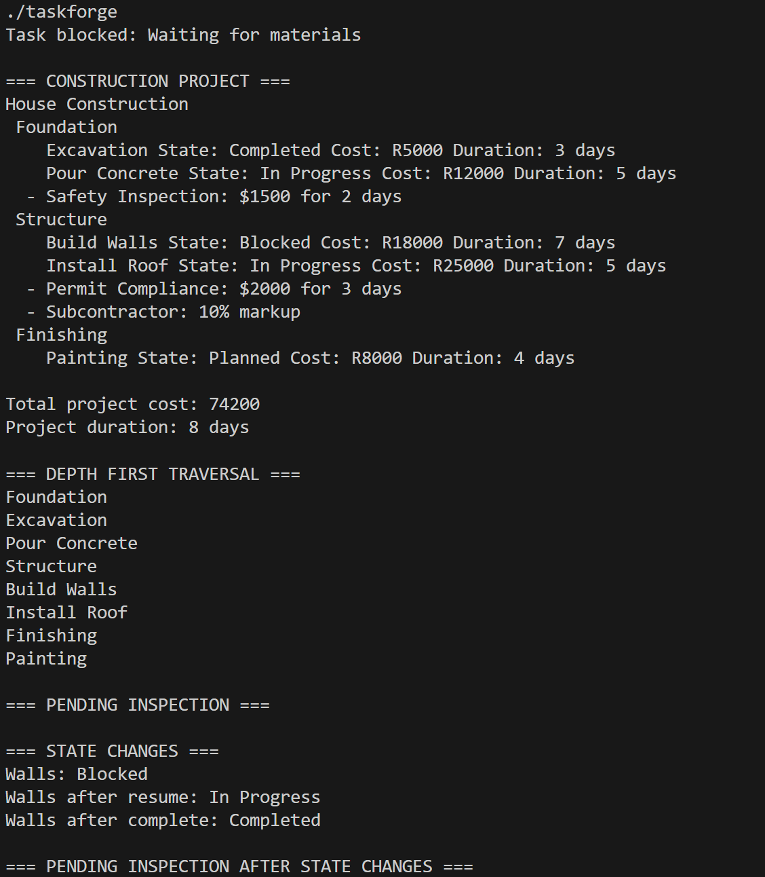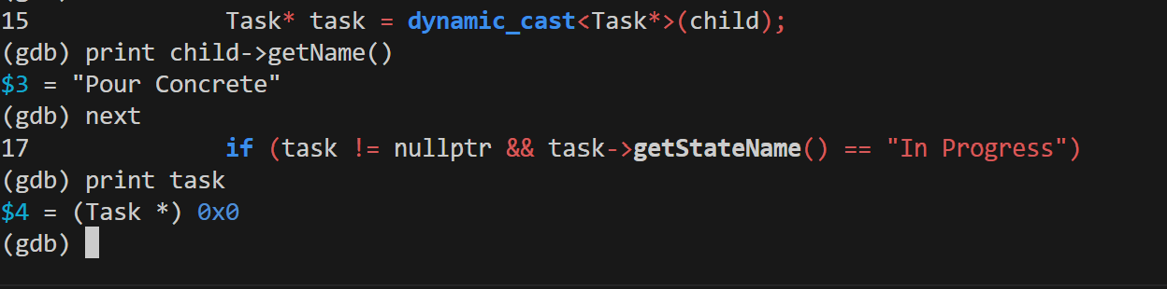
So to correct this problem, we introduced the polymorphic operation: needsInspection(), that determines whether a task is In Progress or not.
bool Task::needsInspection() const {
return getStateName() == "In Progress";
}

Now decorators can forward needsInspection() to the WorkComponent they wrap, and iterator can therefore simply call:
if (child->needsInspection()) {
snapshot.push_back(child);
}

Thus this allows the inspection check to travel through any decorators until it reaches the underlying Task. After this correction, Pour Concrete and Install Roof appeared correctly in the pending inspection traversal.
Valgrind:
